SECTION I

BASIC PRINCIPLES OF MEDICAL IMAGING

1. PIEZOELECTRIC EFFECT:

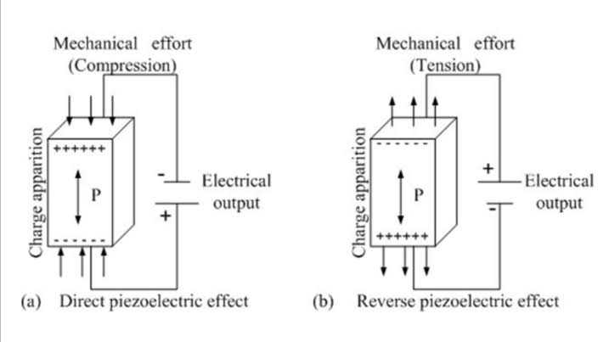

GENERATION OF ULTRASOUND FROM PIEZOELECTRIC CRYSTALS:

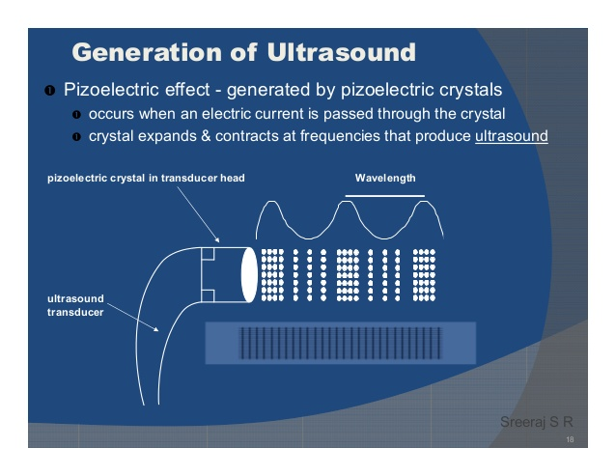

ANALOG TO DIGITAL CONVERTER

LOGARITHMIC COMPENSATION

VOLTAGE PULSE

TRANSMITTER / RECEIVER SWITCH

TRANSDUCER

IMAGE DISPLAY

TIME GAIN COMPENSATION

AMPLIFIER

1. IMAGE PROCESSING TECHNIQUES :

* Image segmentation
* Image enhancement
* Image compression
* Image restoration
* Image registration

1. STRESS STRAIN BEHAVIOUR OF GRAY MATTER AND WHITE MATTER OF BRAIN:



Figure :01 Stress strain behaviour of gray matter of brain

Two curves were plotted – nominal stress strain curve (load divided by the iniial cross-sectional area) and the average stress strain curve. The above figure states that for strains lower than 10%, linear elastic theory is acceptable.



Figure:02: Stress-strain behaviour of white matter of brain

In case of considering the white matter of the brain tissue, it results in a unique behaviour for strains less than 10%. For the strains falling under the range of 10% to 30% , it is shown that the linear elastic theory is acceptable.

(Reference: Sina Mehdizadeh *et al.,* Comparison between brain tissue gray and white matters in tension including necking phenomenon, “Journal of Applied Sciences, ISSN 154-9239)

1. Considering the tissue model to be a linear system, Kramer - Kroneing equation is derived.For a linear and a time invariant system, let h(t) be the impulse response. The frequency response of this system is given by the Fourier transform.

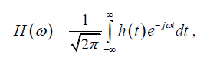

On further simplification process using heaveside functions, the final Kramer- Kroneing equation is derived which are as follows,

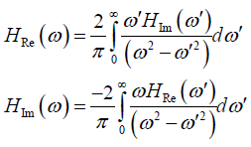

Thus the properties of the considered tissue model could be interpreted based on the real and imaginary parts of the derived equations.

6)

|  |  |  |  |  |
| --- | --- | --- | --- | --- |
| Modality | Ultrasound | X-ray | Computed tomography | Magnetic resonance inaging |
| What is imaged ? | 5 ( blood vessels +fetal monitoring) | 1 (bones) | 2 (Soft tissues + bones) | 3 (Soft tissues + bones+ blood vessels) |
| Safety | 5(highly safe) | 1 | 3 | 4 |
| Spatial resolution | 2(detailed images not obtained) | 3 | 4(excellent resolution) | 3(comparable resolution) |
| Temporal resolution | 5(high temporal resolution) | 2 | 3 | 4 |
| Penetration depth | 2(low penetration depth) | 4 | 4 | 3 |
| Cost | 5(high cost) | 2 | 3 | 3 |
| Speed | 2(longer time for examination) | 4 | 4 | 3 |
| Portability | 4(easily portable) | 2 | 2 | 2 |

7)

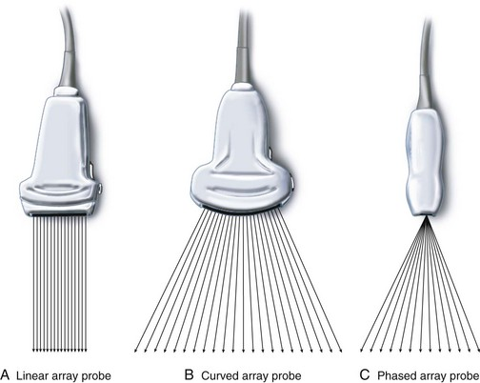 

Linear array transducer Phased array transducer

FACTORS TO BE CONSIDERED IN DESIGNING A PROBE:

* Thickness of the piezoelectric crystal
* Frequency of vibration of the crystal
* To establish electrical contract with a piezoelectric crystal, faces of the crystal are coated with a thin conducting film, and electric contacts are applied.
* To ensure effective transport of sound between crystal and body, protective plastic cover should be used.

8) The artifacts associated with these images may be due to the malfunctioning of the transducers, due to shadowing effect (C) or may be because of the refraction effects(D) . Motion artifacts are yet another reason for artifacts in these images.